WELCOME, STUDENTS OF ENGLISH 122!

Here is your first set of learning opportunities. These are due by May 1st. On that day, at 10 am, I will be hosting a class discussion on Teams during which we will share our thoughts/ideas about these.

- Create a journal entry.
You are living through a monumental historical event, and your memories of it will be valuable historical records in the future, even if only for your own loved ones. I know that many of you are probably keeping a journal already. I want you to share one entry with me. It does not have to be written; it can be a recording (video, audio, or both). I encourage you to be creative; use photographs and/or drawings to augment your writing, if that is the format you choose.

- Read the PowerPoint and the Word Doc on Marxist Theory. Finally, discuss two of the visuals at the end of the slide show through a Marxist lens in a short paragraph or several point form responses for each visual. Feel free to find a few visuals on your own to discuss instead of the ones I have included in the slides. Next week, we will be reading a short story through a Marxist lens, so this is a warm-up to that activity.

- Read the article by Rachel Giese at this link: https://www.macleans.ca/opinion/coronavirus-reveals-how-quickly-governments-and-corporations-can-find-money-when-they-want-to/ -and create a response. Your response should include:

- A brief summary of the article.
- Any bias you notice in the article
- A discussion of two excerpts.
- Your reaction.
Your response should be approximately one page in length.

- Tell me about your reading and/or viewing.
In a few paragraphs, tell me about your current read and/or what you are currently viewing. What do you like, and/or dislike about it? Would you recommend it to others? Why/why not? I found it very difficult to concentrate for any length of time at the beginning of this period, but I am getting better at it every day. I have put a few images on the next page of things I have been reading and viewing. Feel free to include images with your paragraphs as well.

WHAT I HAVE BEEN READING:
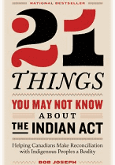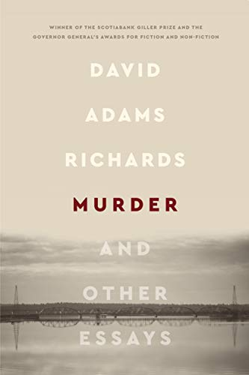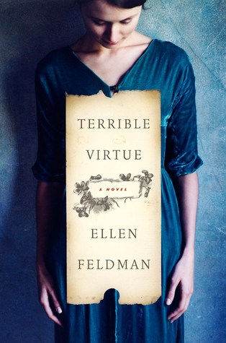
WHAT I HAVE BEEN VIEWING:
